UNIT-4
EXPERIMENT-1
AIM:
To illustrate the use of function templates in C++ that allow a single function to operate on different data types.
DESCRIPTION:
A function template in C++ allows the creation of a generic function that can work with any data type (such as int, float, double, etc.) without rewriting the same code multiple times.
It uses template parameters to represent data types, which are specified when the function is called.
Templates promote code reusability, type safety, and flexibility in programming.
For example, a function template for finding the maximum of two values can work for integers, floats, or characters using the same code definition.
PROGRAM:
// Function Templates
#include<iostream>
using namespace std;
template <typename T>
T add(T a, T b)
{
return a + b;
}
int main()
{ cout << "integers sum= "<< add<int>(5, 3) << "\n";
cout << "double sum= "<< add<double>(2.5, 1.5) << "\n";
cout << "float sum= "<<add<float>(1.44f,1.55f)<<"\n";
return 0;
}

OUTPUT:
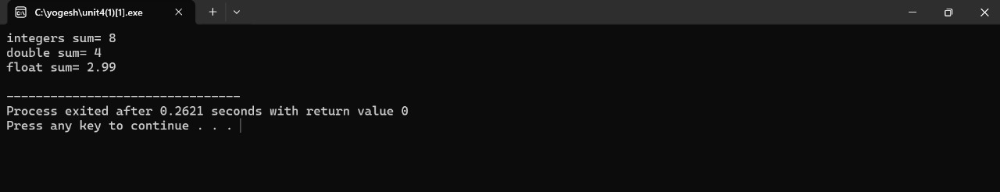
RESULT:
The program successfully demonstrates the use of a function template in C++ that can operate on different data types such as integers, floats, and characters using a single generic function definition.

EXPERIMENT 2
AIM:
To implement a template class in C++ that demonstrates how a single class can handle multiple data types using generic programming.
DESCRIPTION:
A class template in C++ allows the creation of a generic class that can work with different data types without rewriting the same code for each type.
It uses the keyword template followed by a type parameter (like typename T or class T) to define the data type generically.
When an object of the template class is created, the actual data type is specified, and the compiler generates the appropriate class for that type.
Class templates enhance code reusability, type safety, and flexibility in object-oriented programming.
For example, a template class can be written to perform operations such as addition, comparison, or storage for any data type (int, float, double, etc.) using a single class definition.
PROGRAM:
// Class Template : Addition of two numbers
#include <iostream>
using namespace std;
template <typename T1, typename T2> // Class Template for Addition
class Adder
{ private: T1 a;
T2 b;
public:
Adder(T1 x, T2 y)
{
a = x;
b = y;
}
double add()
{ return a + b;
}
};
int main()
{ // int + int
Adder<int, int> obj1(10, 20);
cout << "Addition of int + int = " << obj1.add() << endl;
// int + float
Adder<int, float> obj2(5, 2.5f);
cout << "Addition of int + float = " << obj2.add() << endl;
// double + int
Adder<double, int> obj3(3.5, 4);
cout << "Addition of double + int = " << obj3.add() << endl;
return 0;
}
OUTPUT:
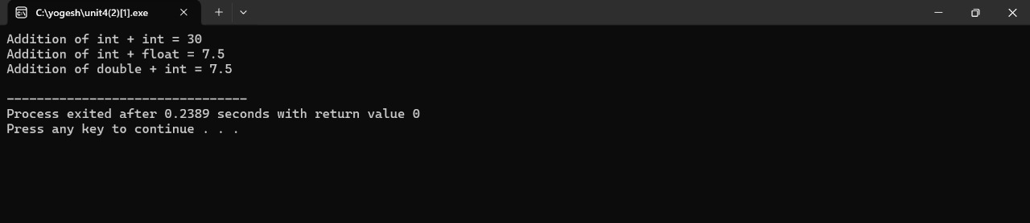
RESULT:
The program successfully demonstrates the implementation of a class template in C++ that performs the addition of two numbers of different data types (int, float, double).
It shows that a single generic class can handle multiple data types using template parameters, thereby promoting code reusability and flexibility in programming.

EXPERIMENT 3
AIM:
To implement a class template with multiple parameters in C++ and demonstrate how a single class can handle operations involving different combinations of data types.
DESCRIPTION:
A class template with multiple parameters allows a programmer to define a generic class that can work with two or more data types simultaneously.
It is declared using multiple type parameters such as template <class T1, class T2>.
When an object of the class is created, the actual data types are passed to the template, and the compiler generates the appropriate class accordingly.
This approach provides greater flexibility, code reusability, and type safety — enabling one class to perform operations on mixed data types (e.g., int + float, double + int, etc.) without writing separate classes for each combination.
PROGRAM:
// Class Template with multiple parameters.
#include <iostream>
using namespace std;
// Class template with two parameters
template <class T1, class T2>
class MyClass {
T1 value1;
T2 value2;
public:
MyClass(T1 v1, T2 v2) // Constructor
{ value1 = v1;
value2 = v2;
}
void display() // Function to display values
{ cout << "Value 1: " << value1 << ", Value 2: " << value2 << endl;
} };
int main() {
MyClass<int, float> obj1(10, 20.5); // Integer and float
obj1.display();
MyClass<string, char> obj2("Hello", 'A'); // String and char
obj2.display();
MyClass<double, int> obj3(99.99, 100); // Double and int
obj3.display();
return 0;
}
OUTPUT:
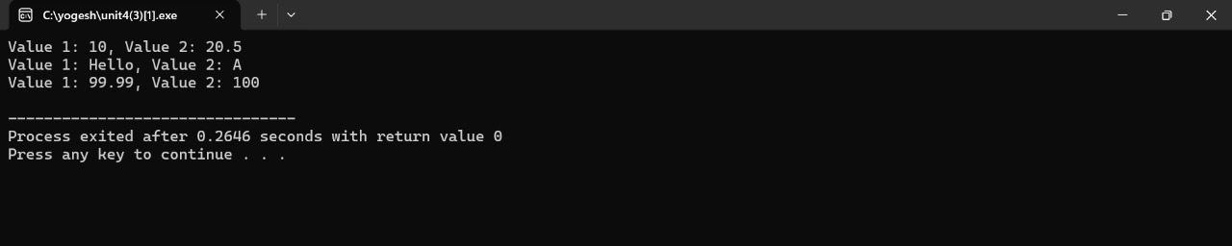
RESULT:
The program successfully demonstrates the implementation of a class template with multiple parameters in C++.
It shows that a single generic class can operate on different combinations of data types by using multiple template parameters, thereby achieving code reusability, type flexibility, and efficiency in generic programming.

